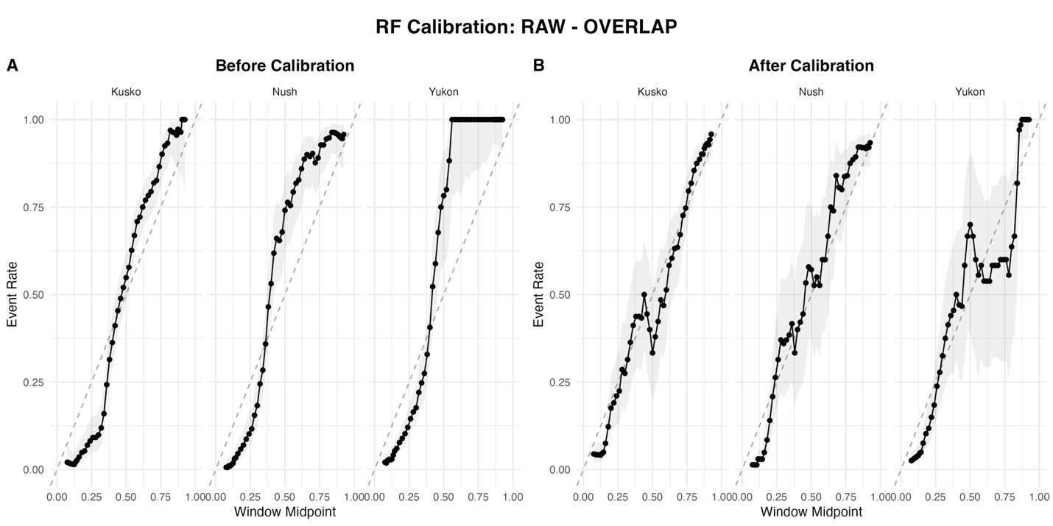
Supplemental Figure 1: Diagrams compare predicted probabilities to observed event rates within sliding windows for each watershed class. Before calibration plots show that predicted probabilities deviate from expected 1:1 relationship. After isotonic calibration predictions much more closely align with observations.

Supplemental information
--- WILL INCLUDE ICMPS SPECIFICATIONS FROM DIEGO –

